**ARDUINO UNO BASED PACKED U CELL INVERTER FOR PHOTOVOLTAIC APPLICATION**

**ABSTRACT**

In the area of renewable energy uses, multilevel inverter still remains a subject matter for research and development to reduce its circuit complexity. Packed U Cell (PUC) multilevel inverter is a recent variant, extensively being used in photovoltaic applications as an alternative to meet the shortage in power demands focusing too much on decreasing the installation cost, increase system’s efficiency, reliability and modularity. It is important to act to decrease this cost through designing a power conditioning circuit with lower cost. To meet this objective ARDUINO UNO is used in generating and providing pulse width modulated (PWM) signals to control the gates of Insulated Gate Bipolar Transistor (IGBT) that constitute the major building block of PUC multilevel inverter. MATLAB/Simulink is used in development of the photovoltaic system which includes PV modules, Maximum Power Point Tracking (MPPT) controller, DC-DC boost converter and PUC inverter. The simulation result validates the merits and performance of this proposed scheme.

**INTRODUCTION**

PV systems are a form of solar energy source where the light in the form of sun rays that are coming from the sun is directly converted into electricity and thus utilized as a renewable form of energy. Certain number of photovoltaic cells is placed together for receiving and producing the required irradiance so that the desired voltage is obtained and this combination of the PV cells forms what is called the solar arrays. Even though, the voltage obtained from solar panel is less and frequently fluctuating, the DC/DC boost converter is placed between the inverter and the solar panel to obtain the desired stable voltage with the help of MPPT controller. In inverter, DC to AC power conversion is due to the power switching devices which are commonly fully controllable semiconductor power switches controlled by the modulation technique generally PWM. Multilevel inverters are highly efficient in generating stepped waveforms with less distortion in comparison to the conventional inverters. Many topologies have been introduced for multilevel inverters utilizing the combination of active switches and multiple isolated or dependent dc sources to generate different voltage levels at the output. In recent years PUC topology has become popular in development of multilevel inverter due to considerable reduction in uses of switches and DC sources. PUC is actually dividing the DC bus voltage in multi levels to decrease the presence of the harmonics in the output load voltage, reducing the size and range of the used filters at the output of the inverter. Among all other proposed topologies in generating higher number of output voltage levels this topology of packed U cell multilevel inverter is a standout based upon the above mentioned advantages. In order to enhance the efficiency of PUC in producing stable output voltage level, in this work ARDUINO UNO is used for generation and use of PWM to control switching sequence.

**EXISTING SYSTEM**

SINGLE phase Transformer less Grid Connected Systems(TLGCS) have become popular over the years due to its reduced size, weight, volume and increased operating efficienc. However, in TLGCS the dc link voltage of the inverter needs to be high. As a result the number of modules that needs to be connected in series becomes large. When large number of modules are connected in series, power yield from the array gets substantially reduced when the modules are subjected to varied environmental conditions such as shading. The topologies derived from H-bridge based inverter and the topologies presented in [14] which use single photo voltaic (PV) source as their input are prone to this mismatched operating problem more because number of series connected modules are more. The topologies derived from neutral point clamped (NPC) based inverter are severely affected by mismatched operating problem as they require double the magnitude of PV voltage compared to conventional H-bridge based inverter topologies.

**EXISTING SYSTEM DISADVANTAGE**

* Inverter efficiency is low
* Harmonics will present
* Coding must be difficult
* Hardware is complicated

**PROPOSED SYSTEM**

The closed loop PUC inverter is shown in figure 8 while its simulink block as developed is shown in figure 9. The block diagram representation of the proposed scheme is shown in figure 10. It may be seen from this block diagram, the Arduino Uno microcontroller is incorporated to provide gate pulse to the power switches controlled by PWM generator and followed by the integration of the whole system in a single model to get the desired result. The switches in Fig. 8 are either IGBT or MOSFET. However, IGBT is considered because of its superiority over MOSFET. There are 6 switches in the PUC inverter which work in pair. Switches S1 & S4, S2 & S5, S3 & S6 works together. A dc source and one capacitor is also used in which the capacitor voltage is kept at 1/3rd of the dc source voltage. Each two switches are connected to a DC bus as U-Cell and these cells build the whole PUC inverter. The DC power output of the PV panel (53V) is boosted up to a level of 160-180V DC by the boost converter, is actually the output power from the PV Panel given to the PUC inverter. The voltage across the capacitor kept at a value of 50-60V DC because, (Vdc = 3 V2). The voltage capacitor (V2) is taken as a feedback reference voltage. The reference voltage is provided via the PWM generator after successfully interfacing it with the Arduino Uno microcontroller and pulse width modulated multicarrier wave is being used for this purpose. The gate pulses to the respective power semiconductor switches are provided by the Arduino controller itself so that timely on-off cycle of the switching pattern is carried out. A LC filter is being attached in between the inverter circuit and the load so that distortion in the output wave is reduced by harmonic loss minimization.

**PROPOSED SYSTEM ADVANTAGE**

* The Arduino Uno controlled gate pulses for development of PUC multilevel inverter using MATLAB/Simulink platform is appeared to be highly efficient.
* The same in PV application incorporating PV models, MPPT and DCDC Boost converter.
* Investigation on further mitigation of the harmonic distortions to obtain better sinusoidal output and to see the effect of increased number of levels and simultaneously reducing the process complexity to achieve near zero THD is under development.

**BLOCK DIAGRAM**

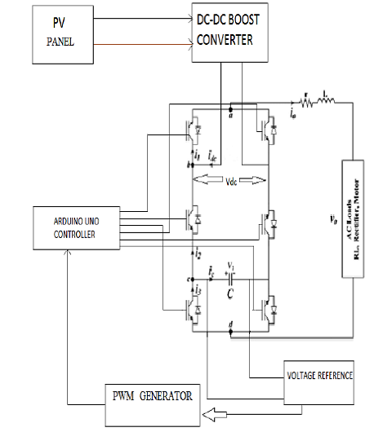

**HARDWARE REQUIREMENT**

* **A**rduino
* **HAHH**Boost converter
* Multi level inverter
* PV panel.

**SOFTWARE REQUIREMENT**

* MATLAB
* Arduino IDE.